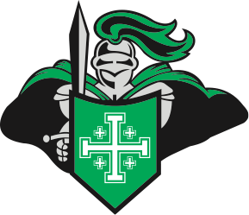
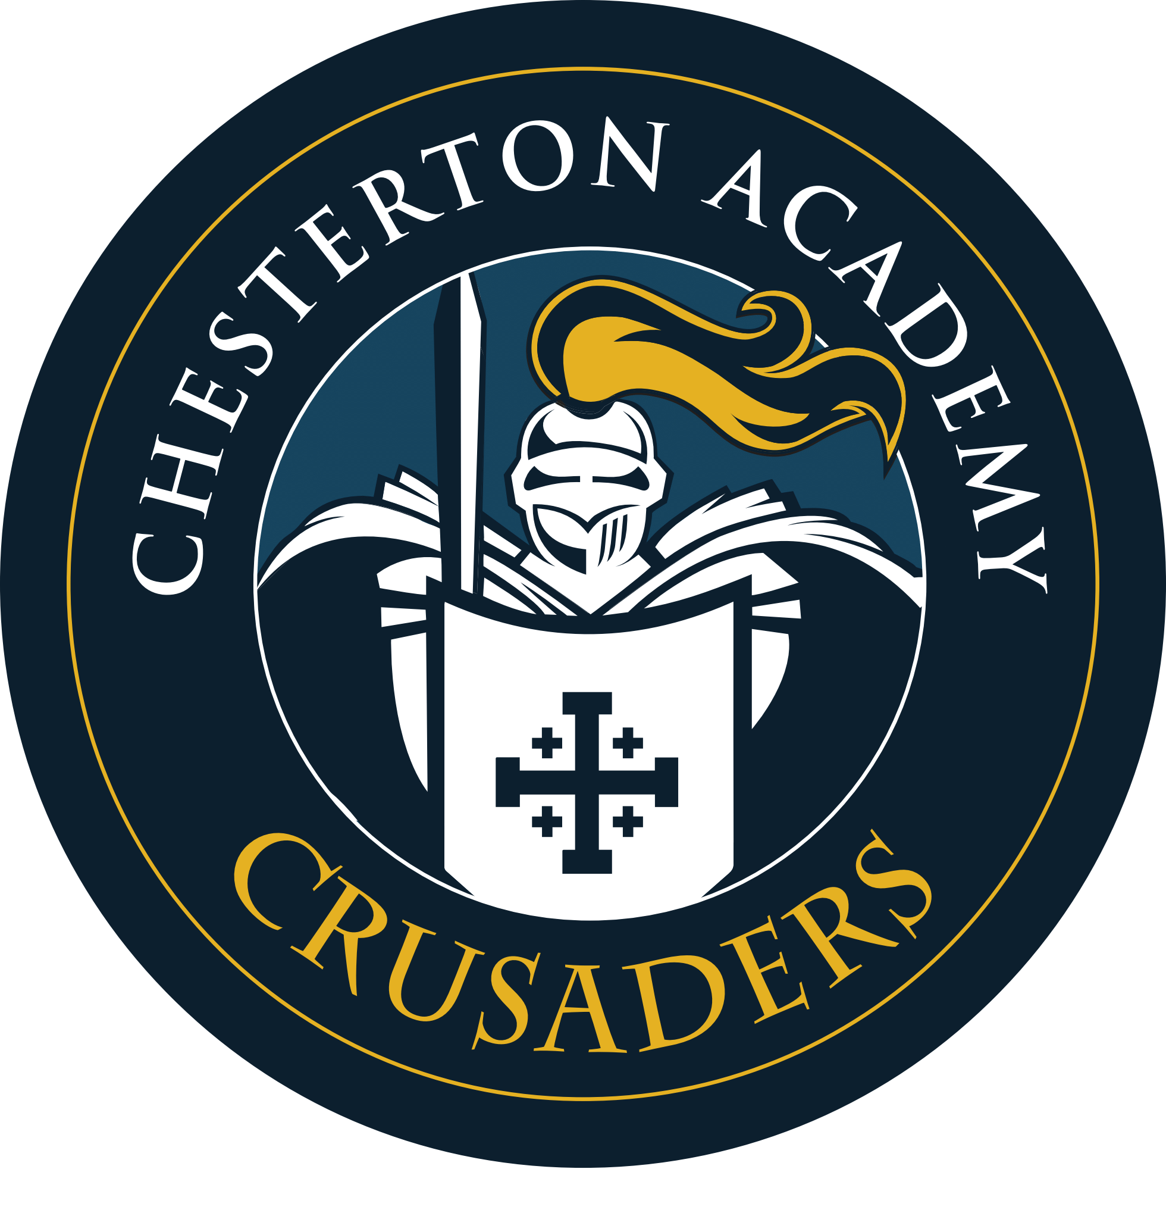
Holy Name Catholic School
Athletic Director -Part-Time

Holy Name Catholic School has an opening for a part-time athletic director.

RESPONSIBILITIES: The AD would oversee all athletics in 4th-12th grades. The AD must follow all MHSAA rules and regulations. The AD would be responsible for all necessary paperwork required by the MHSAA for cooperative agreements or for expanding athletic programs. The AD must be willing to work with Gladstone Public Schools for our cooperative agreement for high school sports.

The AD must be able to attend and supervise all home athletic events. The AD will be responsible for scheduling games, issuing athletic contracts for coaches and referees, hiring/supervising/ evaluating coaches, scheduling referees, setting up for and cleaning after competitions, coordinating volunteers for concession stands, and organizing awards ceremonies for student athletes. The AD is responsible for coordinating and planning athletic budgets, collecting and keeping on file a current physical for each student athlete, collecting and managing all athletic uniforms and equipment, and preparing rosters for tournaments. The AD must keep in contact with coaches, teachers, and parents to ensure that student academic eligibility policies are followed. The AD needs to have excellent organization and communication skills, using e-mail, Remind, and/or other means to communicate important information, reminders, and/or changes to schedules.

HOW TO APPLY: The successful candidate must complete fingerprint scan, federally mandated background check and VIRTUS training. The AD position will be open until filled. If you have any questions about this position please feel free to contact Joseph L. Carlson, Principal.

Joseph L. Carlson - jcarlson@holynamecrusaders.com
409 South 22nd Street
Escanaba, MI 49829
Phone: (906) 786-7550 Ext. 11

COMPENSATION Holy Name Catholic School puts excellent value in our staff. Salary would commensurate with experience and education. Student tuition discounts would also be available.

ABOUT HOLY NAME CATHOLIC SCHOOL: We are a Readiness Kindergarten through High School family, serving about 280 students. We strive to create a school atmosphere where it is "Cool to be Catholic" and an atmosphere where students do not care what you know until they know how much you care. Holy Name Catholic School is in the process of transitioning to a classical liberal arts education. It’s more than a school…It’s a way of life! Thank you for your interest in our school!

Thank you for supporting Holy Name Athletics! GO CRUSADERS!

